JSON

🌟 What is JSON?
# Source: AI Source: Provided by: [Data Path: Persons Table -> ID Column: 1, Name_En Column: Motasem Essam] -> From: [ChatGPT] on [5/31/2026]
JSON (JavaScript Object Notation) is a lightweight data format used to store and exchange data between systems like browsers, servers, and APIs.
It is easy for:
- 👨‍💻 Humans to read
- 🤖 Machines to understand

🎯 Why JSON is Important
# Source: AI Source: Provided by: [Data Path: Persons Table -> ID Column: 1, Name_En Column: Motasem Essam] -> From: [ChatGPT] on [5/31/2026]
JSON is used because it is:
- 📦 Simple and lightweight
- 🔁 Easy to send between client and server
- 🌐 Standard format in APIs
- ⚡ Fast to parse and generate
- 🧩 Supported by almost all programming languages

🔗 Where JSON is Used

1. APIs (Most Important Use)
# Source: AI Source: Provided by: [Data Path: Persons Table -> ID Column: 1, Name_En Column: Motasem Essam] -> From: [ChatGPT] on [5/31/2026]
Servers send data to apps in JSON format.
Example:
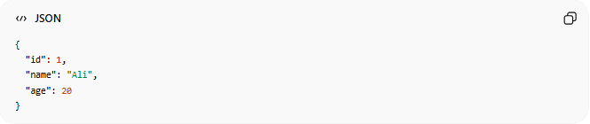
{
"id": 1,
"name": "Ali",
"age": 20
}

2. Web Applications
# Source: AI Source: Provided by: [Data Path: Persons Table -> ID Column: 1, Name_En Column: Motasem Essam] -> From: [ChatGPT] on [5/31/2026]
Frontend apps use JSON to get data from backend servers.

3. Mobile Applications
# Source: AI Source: Provided by: [Data Path: Persons Table -> ID Column: 1, Name_En Column: Motasem Essam] -> From: [ChatGPT] on [5/31/2026]
Apps like Uber, Instagram, and banking apps use JSON to communicate with servers.

4. Configuration Files
# Source: AI Source: Provided by: [Data Path: Persons Table -> ID Column: 1, Name_En Column: Motasem Essam] -> From: [ChatGPT] on [5/31/2026]
Used in software settings:
- package.json (Node.js)
- settings.json (VS Code)

🧠 Simple Idea
# Source: AI Source: Provided by: [Data Path: Persons Table -> ID Column: 1, Name_En Column: Motasem Essam] -> From: [ChatGPT] on [5/31/2026]
Think of JSON as a:
📦 Delivery box label
It tells:
- What is inside
- How it is structured
- How to read it

🔄 How JSON Works in Real Life
# Source: AI Source: Provided by: [Data Path: Persons Table -> ID Column: 1, Name_En Column: Motasem Essam] -> From: [ChatGPT] on [5/31/2026]
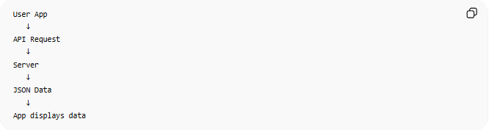
User App
↓
API Request
↓
Server
↓
JSON Data
↓
App displays data

⚖️ JSON vs Plain Text
# Source: AI Source: Provided by: [Data Path: Persons Table -> ID Column: 1, Name_En Column: Motasem Essam] -> From: [ChatGPT] on [5/31/2026]
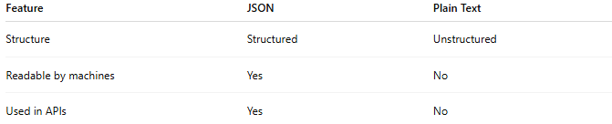
Feature | JSON | Plain Text
Structure | Structured | Unstructured
Readable by machines | Yes | No
Used in APIs | Yes | No

📌 Key Idea
# Source: AI Source: Provided by: [Data Path: Persons Table -> ID Column: 1, Name_En Column: Motasem Essam] -> From: [ChatGPT] on [5/31/2026]
JSON is not a programming language.
It is only a data format used for communication.

🧭 Summary
# Source: AI Source: Provided by: [Data Path: Persons Table -> ID Column: 1, Name_En Column: Motasem Essam] -> From: [ChatGPT] on [5/31/2026]
JSON is a lightweight, structured data format used to exchange information between systems, especially in APIs and web applications. It is the most common format for modern data communication.

